**Python Django**

# D:\Shalini Project\Screenshots\Untitled30.pngFor Django installation

Open command prompt

Run > pip install Django

After successful installation of django

For checking the Django version > python -m django --version

Django have many inbuilt commands, for seeing that > django-admin

# For creating a new project

Create a folder in any directory

For creating a new project in that folder, open command prompt for that particular folder.

Run the below code for creating a new project,

* django-admin startproject *projectname*

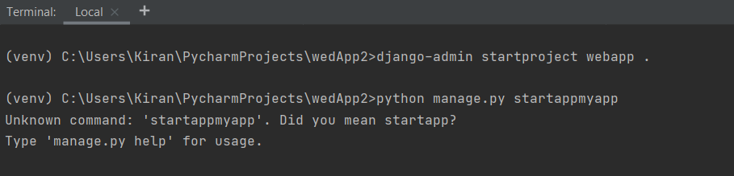

You can see a folder has automatically created with our project name.

Here one folder and a manage.py file have created. Inside the folder we can find some python files also.

This manage.py file is for communicating with our command line.

# For running the file

We need to create a webserver.

* python manage.py runserver

The default port number is 8000. So, we can run our project on browser by,

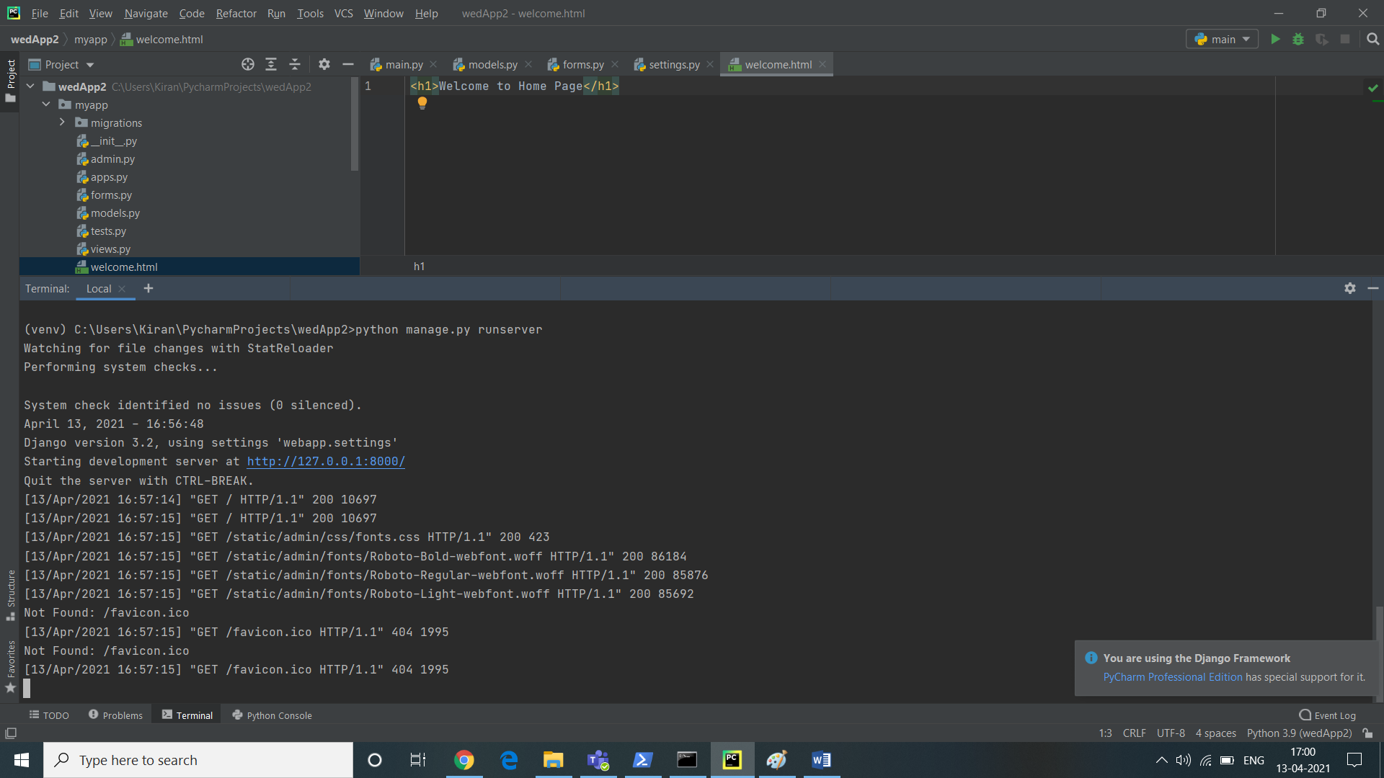

< localhost:8000

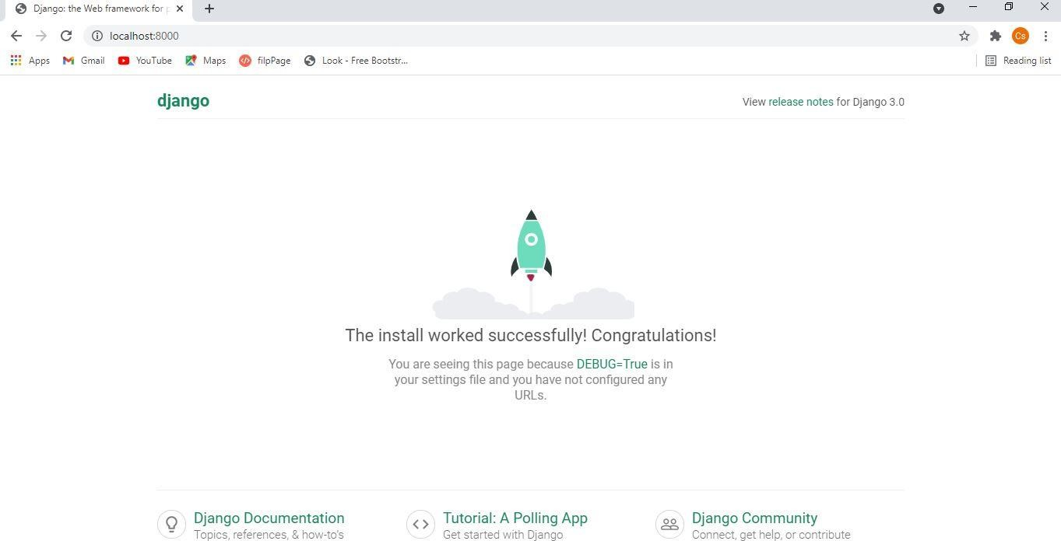

This is the default Django page!

* Creating App (sections)
* python manage.py startapp myapp

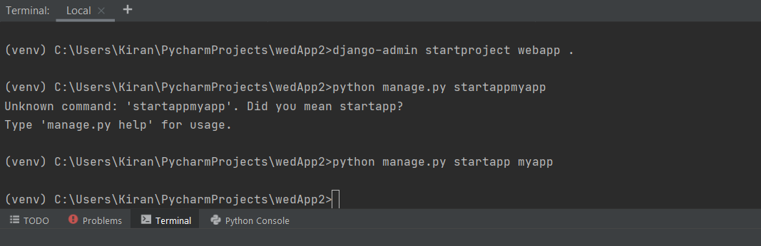

* **Opening folder on PyCharm** (with virtual environment)

*In PyCharm, rather than creating virtual environment by command, we can directly create it while creating a new project.*

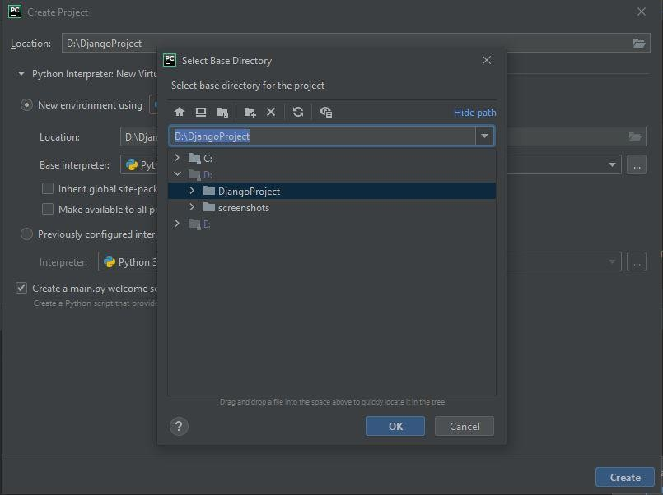Files -> New Project -> *open our folder* -> create

# Building our design

forms.py

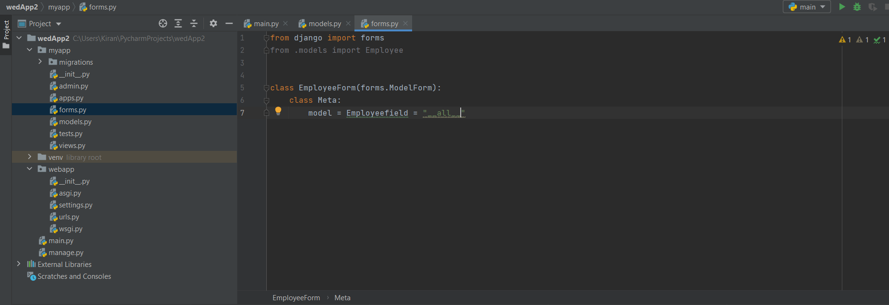

Now we need to set the root for this.

*We need to specify the app’s root as well as project roots*

>Project root setting urls.py in project (webapp) path

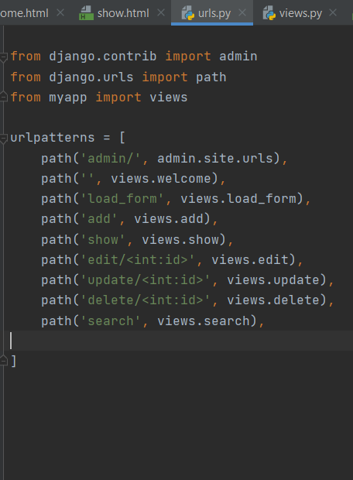

# Modules

For keeping data, we use databases. In Django’s concept we don’t create

tables, we create models.

models.py webapp

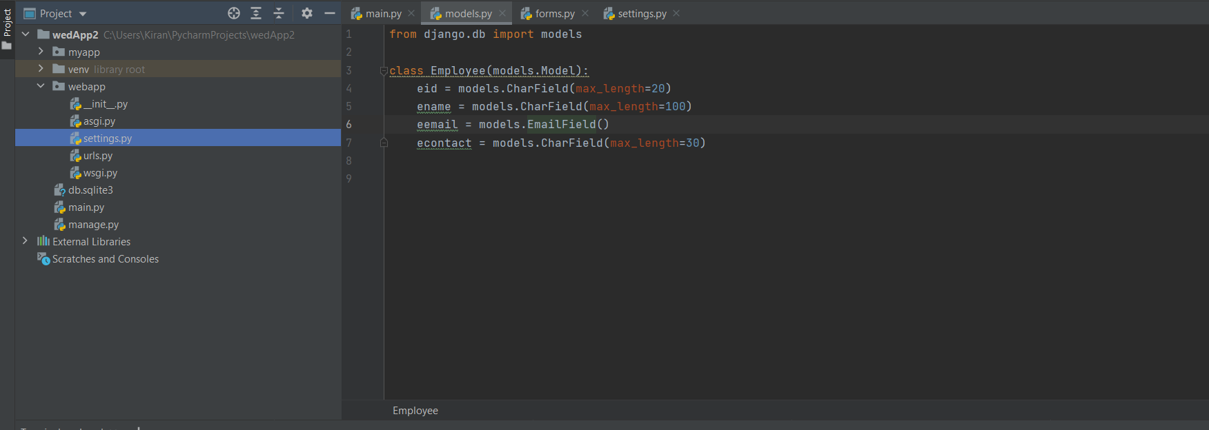

Creating tables (Migrations)

* 1. Model creation (at model.py file)
  2. Go to settings.py in project (webapp) -> check for our app configuration

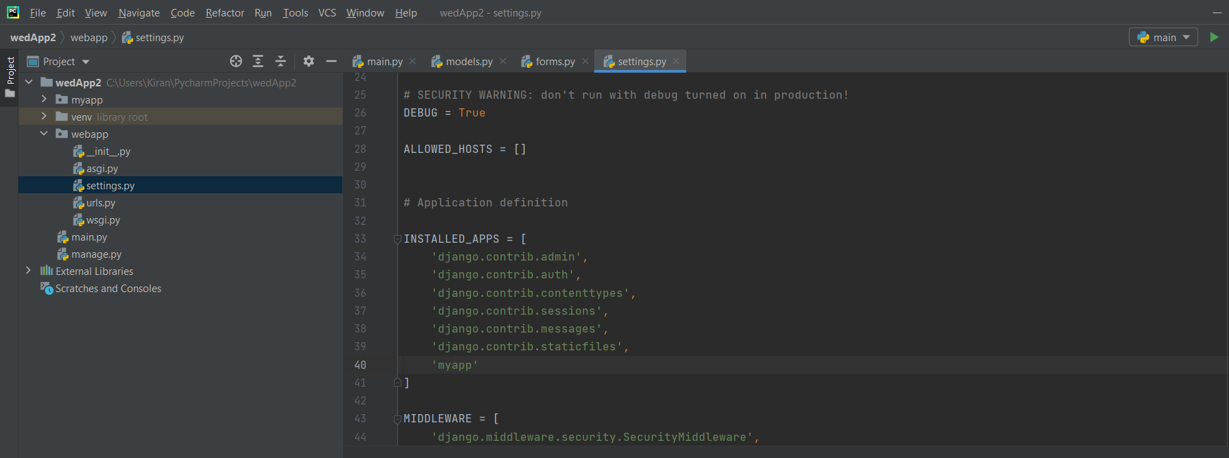

* 1. Go to Welcome.html in project(webapp)->

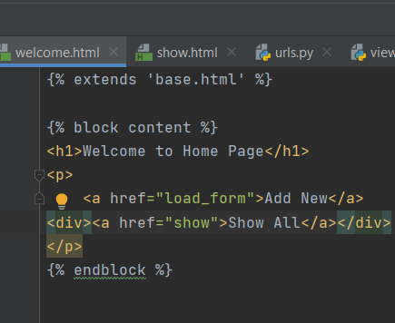

4.>python manage.py makemigrations

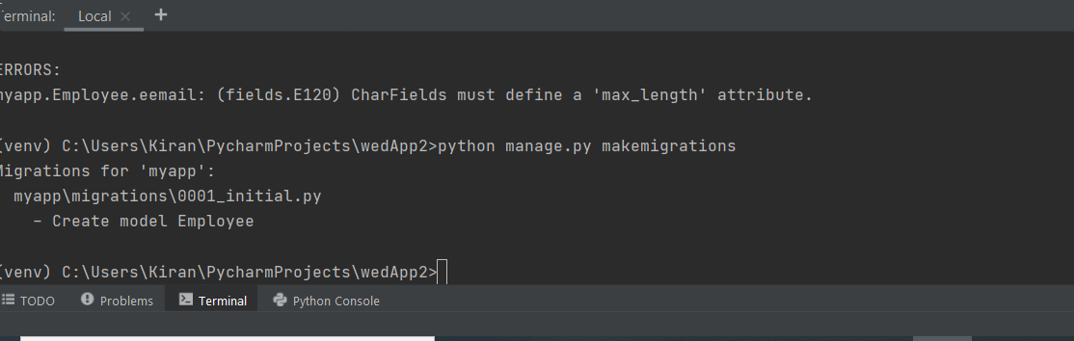

----------------table formed at migrations->0001_initial.py--------------------------

* **For creating database table**, we need to run this migration

>python manage.py migrate

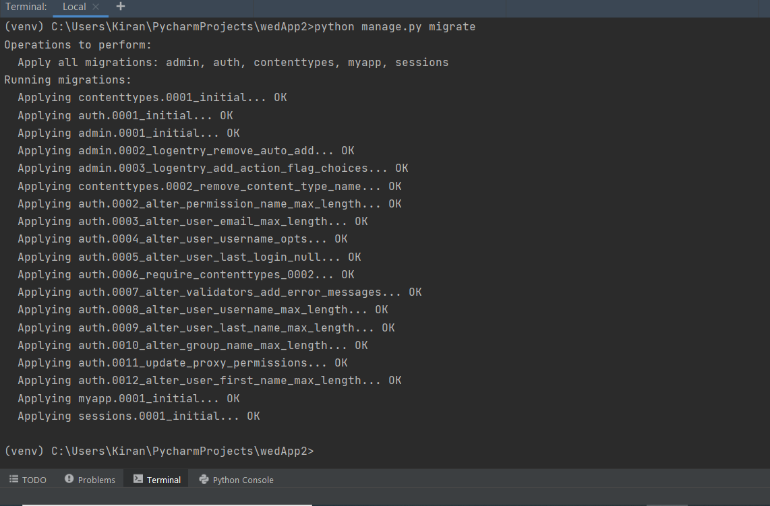………..Database table created!!.........

# Creating Admin Panel

Check Django inbuilt admin panel <localhost/8000/admin/

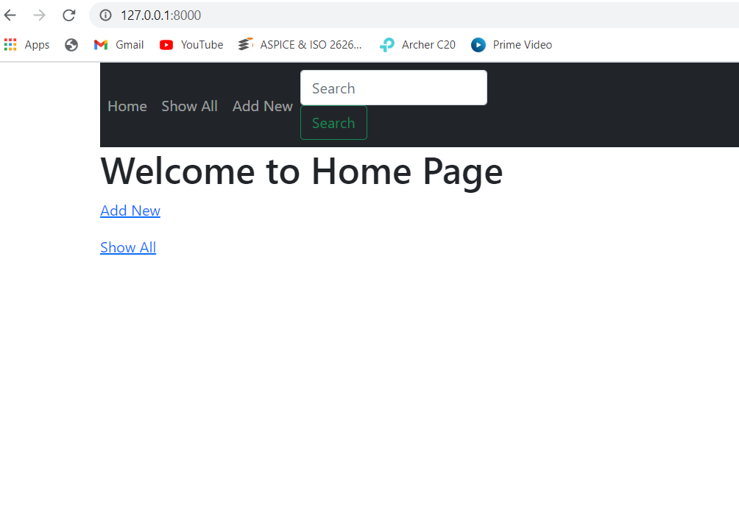

………..index.html……..

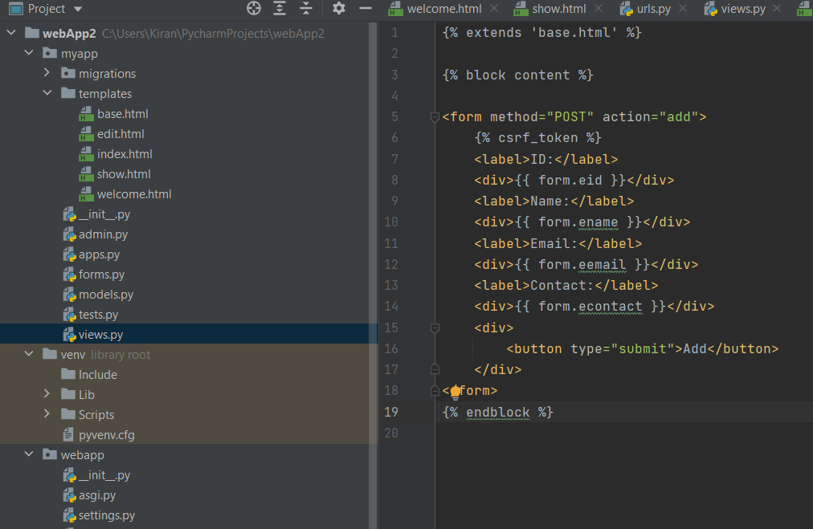

Index table has added to the admin panel

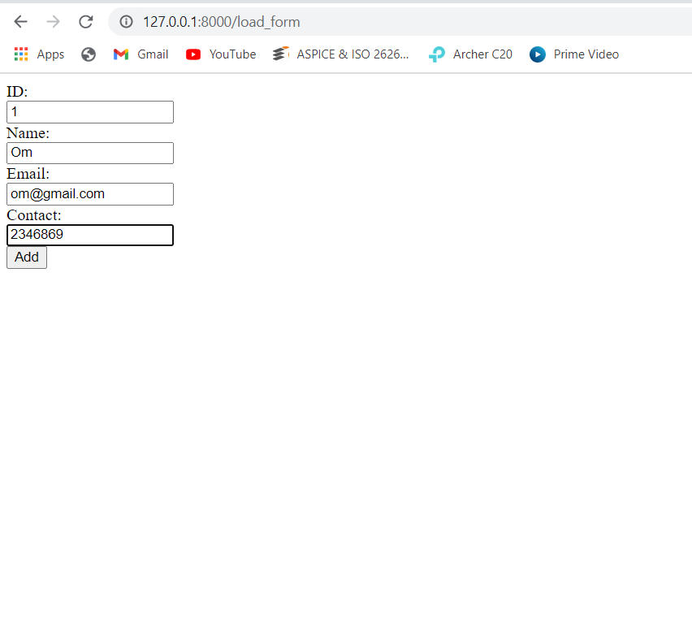

Login to admin page with same credentials

* Creating an interface for app (webapp)

Go to show.html products

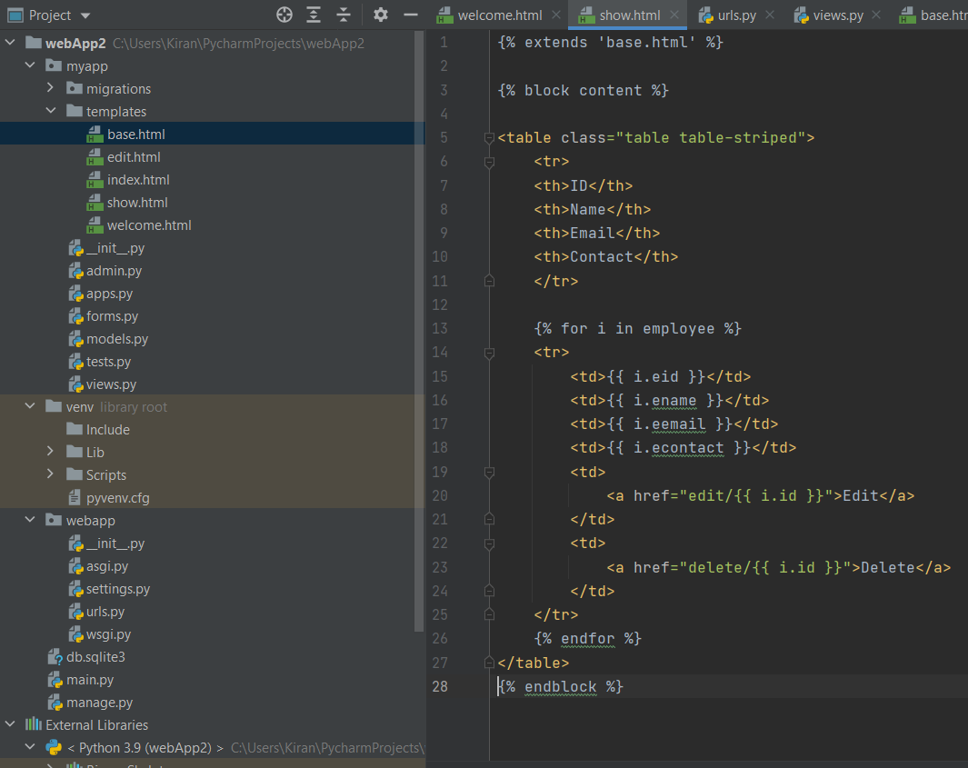

show table has showing to the admin panel

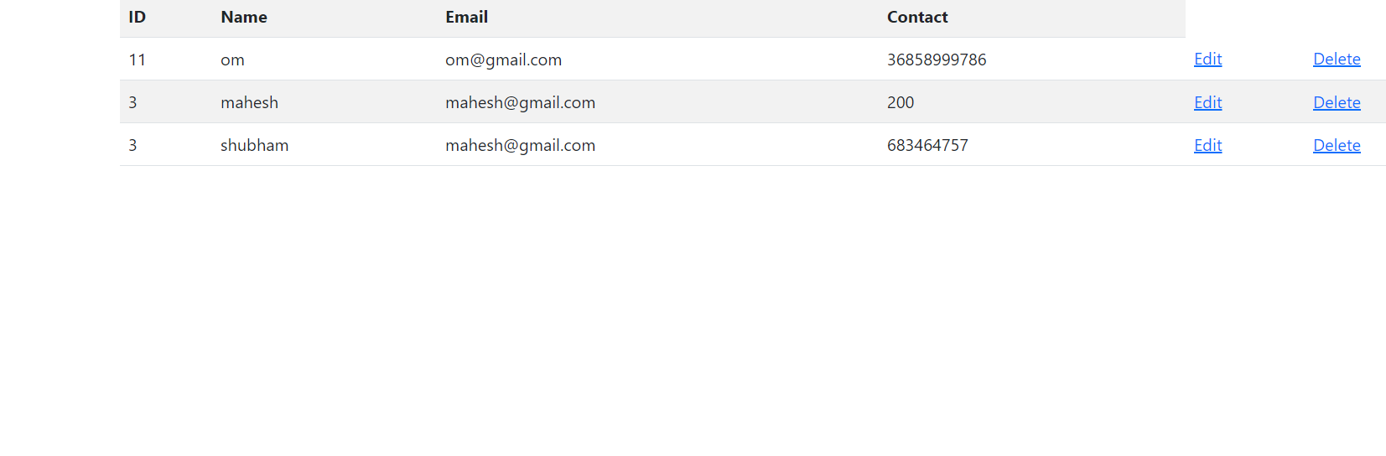

We can add details of the Employee here.

……….Details have been displayed

# Taking values from database

Create a user interface to see the values

>new (myapp) > directory > (templates)

> (templates)> new > html5 file (index)

--------------views.py…………………………………………….

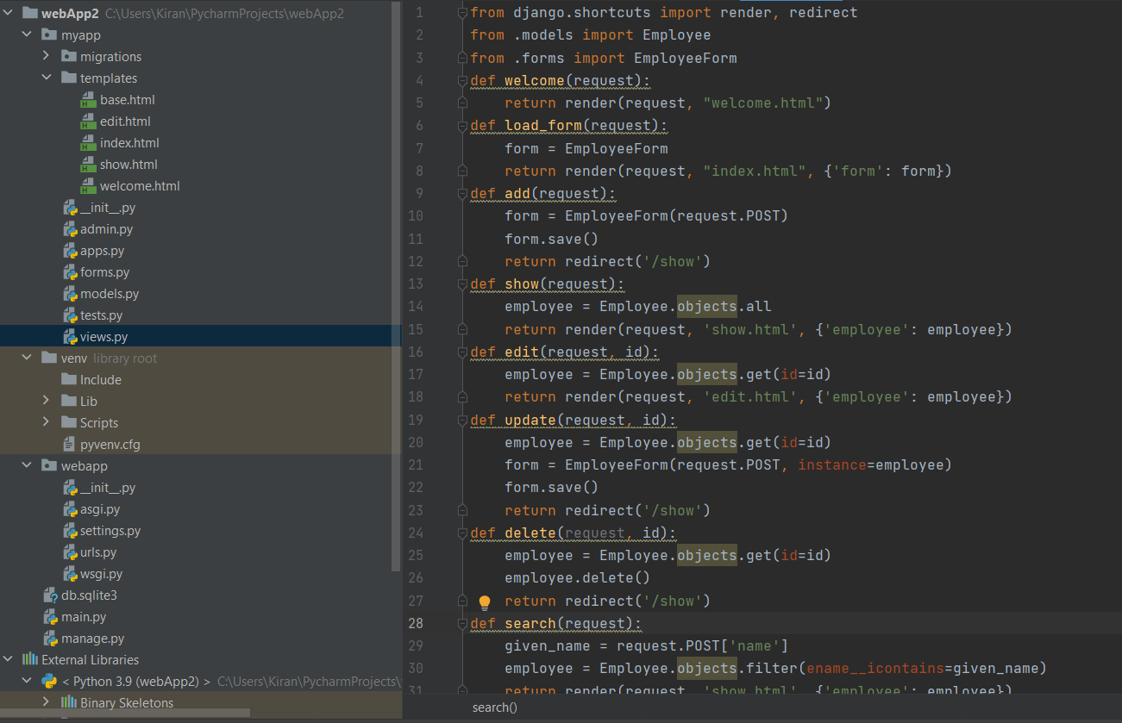

Like this we can take values from the database and display it.

# For beautifying the template using bootstrap (if needed)

Edit.html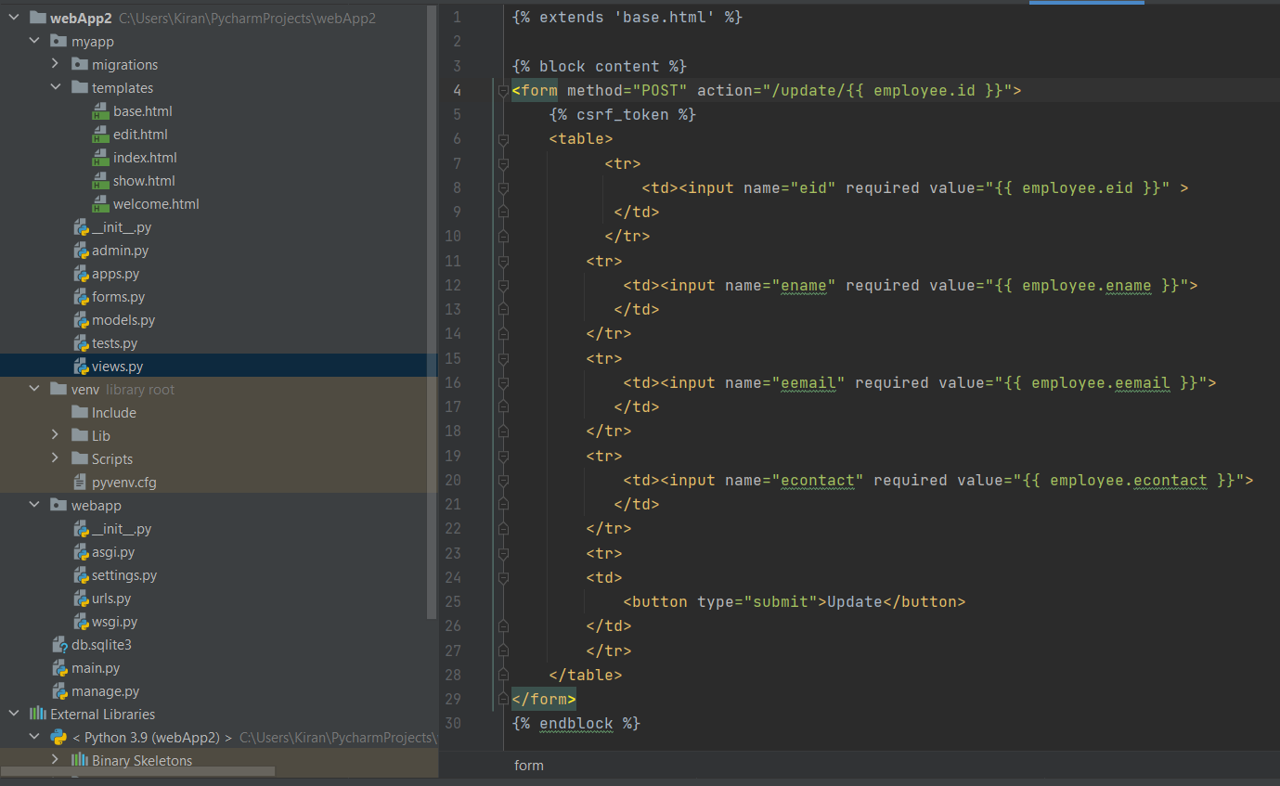

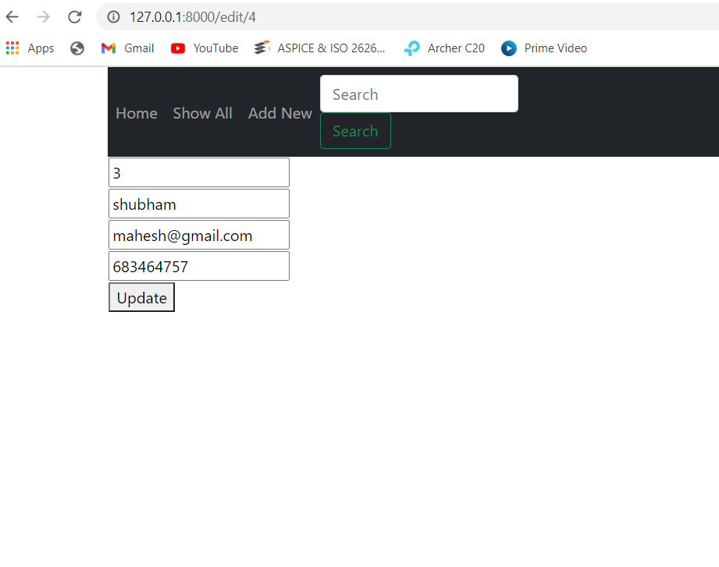

base.html

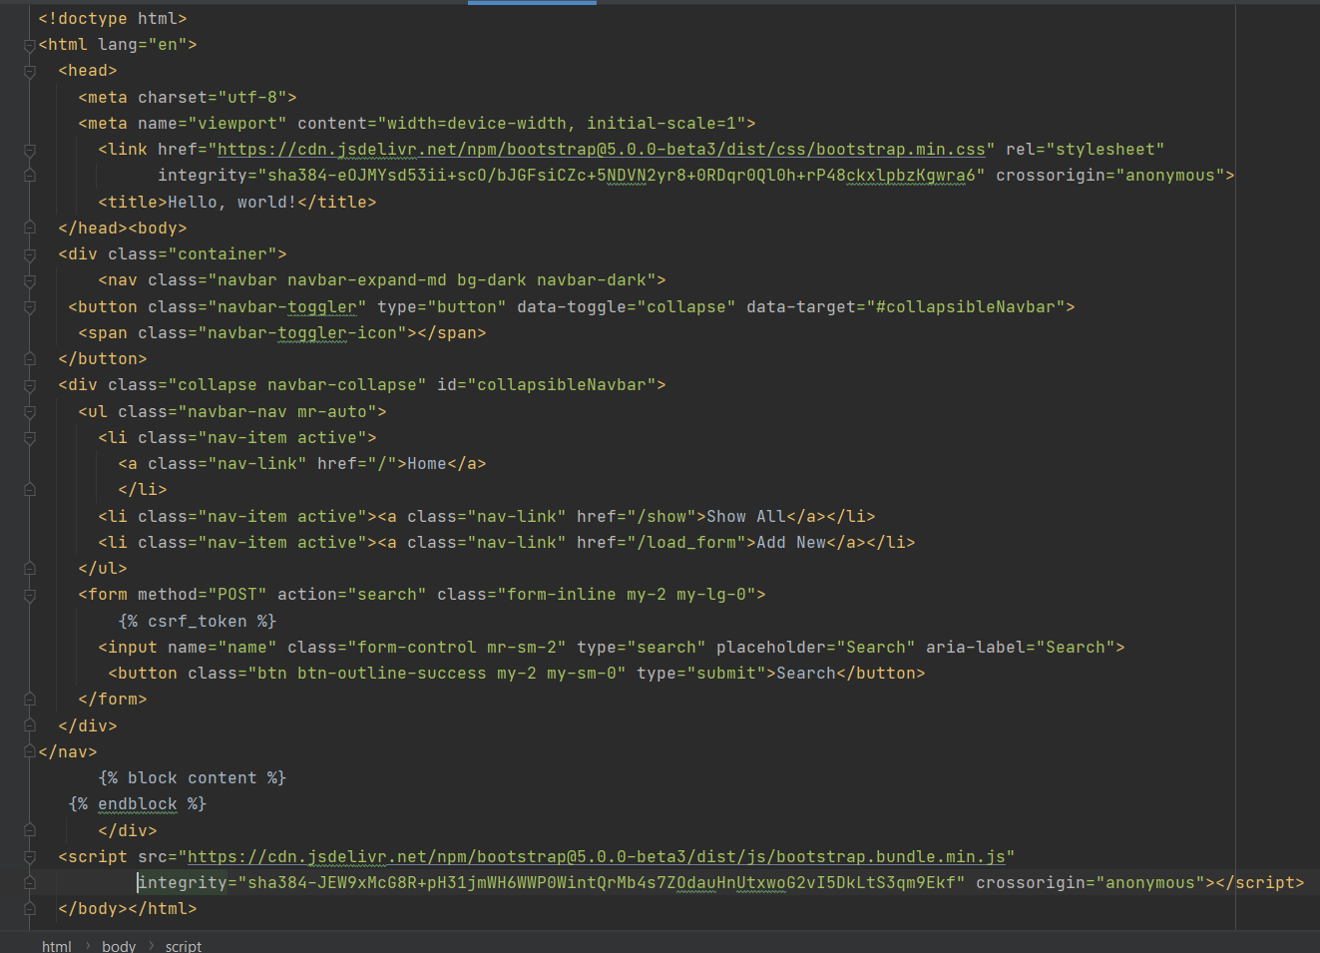

User Interface

